Chapter 3 The Early Inhabitants of South Carolina

TRUE/FALSE

1. Prehistoric refers to a period of time before written records were kept.

ANS: T PTS: 1 DIF: Comprehension
REF: Chapter 3 Section 1 TOP: Prehistoric Indians

2. The most common theory of man’s arrival in North America says he arrived by boat from Asia.

ANS: F
The most common theory of man’s arrival in North America says he came by foot from Siberia to Alaska.

PTS: 1 DIF: Application REF: Chapter 3 Section 1
TOP: Prehistoric Indians

3. The earliest period of the history of American Indians is known as the Archaic period.

ANS: F
The earliest period of the history of American Indians is known as the Paleo period.

PTS: 1 DIF: Knowledge REF: Chapter 3 Section 1
TOP: Prehistoric Indians

4. Wooly mammoths and mastodons were found in the Paleo period.

ANS: T PTS: 1 DIF: Knowledge REF: Chapter 3 Section 1
TOP: Prehistoric Indians

5. The last prehistoric period of history was the Mississippian period.

ANS: T PTS: 1 DIF: Knowledge REF: Chapter 3 Section 1
TOP: Prehistoric Indians

6. The Indians who lived during the Archaic period began to form settlements and became farmers.

ANS: F
The Indians who lived during the Archaic period were hunters and gatherers.

PTS: 1 DIF: Comprehension REF: Chapter 3 Section 1
TOP: Prehistoric Indians

7. American Indians in South Carolina grew squash, pumpkins, beans, corn, gourds, and sunflowers.

ANS: T PTS: 1 DIF: Knowledge REF: Chapter 3 Section 2
TOP: Historic Indians

8. Tepees were a common form of Indian shelter in South Carolina.

ANS: F
The most typical dwelling was the wigwam, a circular or oblong house.

PTS: 1 DIF: Application REF: Chapter 3 Section 2
TOP: Historic Indians

9. Indians were careful to preserve the environment since it played an important role in their lives.

ANS: T PTS: 1 DIF: Comprehension
REF: Chapter 3 Section 2 TOP: Historic Indians

10. Paleo Indians often killed animals unnecessarily.

ANS: T PTS: 1 DIF: Comprehension
REF: Chapter 3 Section 1 TOP: Prehistoric Indians

11. Before European contact, Indians had no horses and had to travel by water or foot.

ANS: T PTS: 1 DIF: Comprehension
REF: Chapter 3 Section 2 TOP: Historic Indians

12. According to Columbus, the people that he found in the New World were uneducated and not to be trusted.

ANS: F
According to Columbus, the people that he found in the New World were intelligent and generous.

PTS: 1 DIF: Comprehension REF: Chapter 3 Section 3
TOP: Early Explorers

MULTIPLE CHOICE

1. What type of scientists study the origin and development of humans?
A. | anthropologists
B. | archaeologists
C. | economists
D. | sociologists

ANS: A PTS: 1 DIF: Comprehension
REF: Chapter 3 Section 1 TOP: Prehistoric Indians

2. What are items (such as pottery shards, weapons, tools, jewelry) once used by ancient peoples called?
A. | antiques
B. | artifacts
C. | fossils
D. | heirlooms

ANS: B PTS: 1 DIF: Comprehension
REF: Chapter 3 Section 1 TOP: Prehistoric Indians

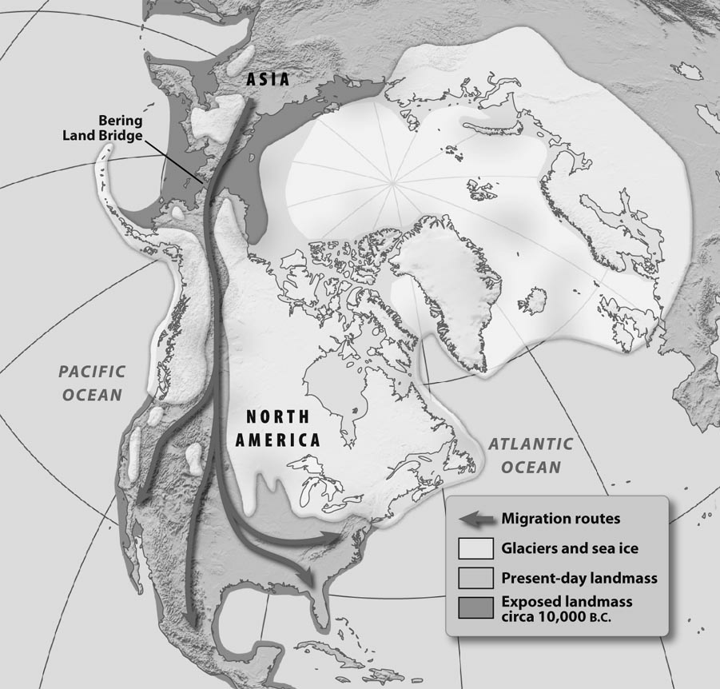

3. Which statement BEST explains the information on the map?
A. | The British Isles were islands.
B. | There is less land in the world today.
C. | There were no glaciers in the United States.
D. | The east coast of the United States has not changed.

ANS: B PTS: 1 DIF: Analysis REF: Chapter 3 Section 1
TOP: Prehistoric Indians

4. According to the map, how far south did the people who came to North America via the Bering Strait move?
A. | They moved as far south as Mexico.
B. | They moved as far south as Canada.
C. | They moved as far south as Guatemala.
D. | They moved as far south as the United States.

ANS: A PTS: 1 DIF: Analysis REF: Chapter 3 Section 1
TOP: Prehistoric Indians

5. Which characteristic describes the earliest peoples in North America?
A. | They were farmers.
B. | They were nomads.
C. | They were gatherers.
D. | They were fishermen.

ANS: B PTS: 1 DIF: Comprehension
REF: Chapter 3 Section 1 TOP: Prehistoric Indians

6. Which statement describes geographic conditions in North America when early people migrated from Asia?
A. | There was more dry land than there is today.
B. | There was abundant food to support more people.
C. | There were no mountains to hinder the movement of people.
D. | There was a system of rivers and streams to permit easy travel.

ANS: A PTS: 1 DIF: Application REF: Chapter 3 Section 1
TOP: Prehistoric Indians

7. What was the name of the era in which the first American Indians lived?
A. | Archaic Indian Era
B. | Mississippian Indian Era
C. | Paleo Indian Era
D. | Pre-Projectile Point Era

ANS: C PTS: 1 DIF: Knowledge REF: Chapter 3 Section 1
TOP: Prehistoric Indians

8. What brought about a change in the diet of early people?
A. | the discovery of fire
B. | a move to a new place
C. | a longer growing season
D. | the disappearance of large animals

ANS: D PTS: 1 DIF: Application REF: Chapter 3 Section 1
TOP: Prehistoric Indians

9. During which period of time was the first pottery made?
A. | Archaic period
B. | Mississippian period
C. | Paleo period
D. | Woodland period

ANS: A PTS: 1 DIF: Knowledge REF: Chapter 3 Section 1
TOP: Prehistoric Indians

10. What new way of acquiring food was begun during the Woodland period?
A. | farming
B. | trading
C. | fishing and herding
D. | hunting and gathering

ANS: A PTS: 1 DIF: Knowledge REF: Chapter 3 Section 1
TOP: Prehistoric Indians

11. During which time period did agriculture begin?
A. | Archaic Period
B. | Mississippian Period
C. | Paleo Period
D. | Woodlands Period

ANS: D PTS: 1 DIF: Knowledge REF: Chapter 3 Section 2
TOP: Prehistoric Indians

12. What protected Mississippian villages from their enemies?
A. | guards
B. | guns
C. | palisades
D. | towers

ANS: C PTS: 1 DIF: Comprehension
REF: Chapter 3 Section 1 TOP: Prehistoric Indians

13. Which time period included the moundbuilders?
A. | Archaic period
B. | Mississippian period
C. | Paleo period
D. | Woodland period

ANS: B PTS: 1 DIF: Knowledge REF: Chapter 3 Section 1
TOP: Prehistoric Indians

14. Which time period was the last of the prehistoric eras?
A. | Archaic period
B. | Mississippian period
C. | Paleo period
D. | Woodland period

ANS: B PTS: 1 DIF: Knowledge REF: Chapter 3 Section 1
TOP: Prehistoric Indians

15. How were the American Indians largely responsible for the success of European settlements?
A. | They provided the Europeans with shelter.
B. | They shared their land with the Europeans.
C. | They taught the Europeans how to grow certain crops.
D. | They led the Europeans to large deposits of gold and silver.

ANS: C PTS: 1 DIF: Analysis REF: Chapter 3 Section 2
TOP: Historic Indians

16. Why did diseases, like smallpox, affect American Indians more than Europeans?
A. | Europeans had been vaccinated against the diseases.
B. | Europeans had a natural immunity to the various diseases.
C. | The American Indians had no prior exposure to the diseases.
D. | The poverty-like conditions in which the American Indians lived caused the diseases to spread.

ANS: C PTS: 1 DIF: Analysis REF: Chapter 3 Section 2
TOP: Historic Indians

The Cherokee

The Cherokee were the only Iroquoian-speaking member of the five Civilized Tribes, located in the southeastern United States. Their accomplishments as a civilized culture were considerable. They adopted a written constitution as the basis for their government. They established a system of courts for justice and a system of schools to educate their people. One of their leaders, Sequoyah, developed a system of written language symbols, the syllabary. Almost the complete population was literate, or able to read and write that language. The Cherokee published their own newspaper, The Phoenix, in English as well as in their native language.

The Cherokee were agricultural people who lived together in large villages of about 30 to 60 homes. Their homes surrounded a large Council House located in the middle of the village. The Council House was used for religious ceremonies, governmental or council meetings, and general meetings or conferences. The sacred fire of the Cherokee was maintained in the Council House.

The major crops grown by the Cherokee included corn, beans, and squash. Their meats were obtained by hunting. The Cherokee enjoyed a standard of living envied by many of the Europeans settlers who came into South Carolina.

17. Based on the information in the reading, which major agricultural products were produced by the Cherokee?
A. | livestock, corn, and tomatoes
B. | livestock, wild plants, nuts, and berries
C. | squash, beans, and corn
D. | tomatoes, beans, and corn

ANS: C PTS: 1 DIF: Comprehension
REF: Chapter 3 Section 2 TOP: Historic Indians

18. Based on the information in the reading, what language was spoken by the Cherokee?
A. | English
B. | Iroquoian
C. | Muskhogean
D. | Siouan

ANS: B PTS: 1 DIF: Comprehension
REF: Chapter 3 Section 2 TOP: Historic Indians

The Origin of Earth
A Cherokee Myth

The earth is a great island floating in a sea of water, and suspended at each of the four cardinal points by a cord hanging down from the sky vault, which is of solid rock. When the world grows old and worn out, the people will die and the chords will break and let the earth sink down into the ocean, and all will be water again. The Indians are afraid of this . . . .

When the animals and plants were first made--we do not know by whom--they were told to watch and keep awake for seven nights. . . . They tried to do this, and nearly all were awake through the first night, but the next night, several dropped off to sleep, and the third night, others were asleep, and then others, until on the seventh night, of all the animals only the owl, the panther, and one or two more were still awake. To these were given the power to see and go about in the dark, and to make prey of the birds and animals which must sleep at night. Of the trees, only the cedar, the pine, and spruce, the holly and the laurel were awake to the end, and to them it was given to be always green and to be greatest for medicine, but to the others it was said: “Because you have not endured to the end, you shall lose your hair every winter.”

Source: James Mooney, Myths of the Cherokee and Sacred Formulas of the Cherokee (Nashville: Charles and Randy Elder, 1982), pp. 239-240.

19. Based on the Cherokee myth, why are cedars, pines, spruces, hollys, and laurels evergreen?
A. | They were resting places of the owls.
B. | They remained awake for seven nights.
C. | They were the tallest of the trees on Earth.
D. | They received most of the water they needed from the ocean.

ANS: B PTS: 1 DIF: Comprehension
REF: Chapter 3 Section 2 TOP: Historic Indians

20. According to the Cherokee myth, how will the world end?
A. | The world will end in an explosion or fire.
B. | The world will end when all creatures fall asleep.
C. | The world will end when all the Cherokee people are gone.
D. | The world will end when the cords break and drop the world back into the ocean.

ANS: D PTS: 1 DIF: Comprehension
REF: Chapter 3 Section 2 TOP: Historic Indians

21. Which statement BEST describes the Indian population of South Carolina when the Europeans arrived?
A. | There were very few Indians.
B. | Indians numbered in the millions.
C. | The number of Indians in present-day Mexico was less than that in present-day South Carolina.
D. | There were more Indians in what is now South Carolina than in any other area of North America.

ANS: A PTS: 1 DIF: Analysis REF: Chapter 3 Section 2
TOP: Historic Indians

22. The main source of livelihood for nomadic tribes was
A. | vegetables
B. | _{large game}
C. | small game
D. | fish

ANS: B PTS: 1 DIF: Application REF: Chapter 3 Section 1
TOP: Prehistoric Indians

23. What was the overall organization of a Native American society called?
A. | clan
B. | family
C. | region
D. | tribe

ANS: D PTS: 1 DIF: Comprehension
REF: Chapter 3 Section 2 TOP: Historic Indians

24. Where did Columbus first land in the New World?
A. | Barbados
B. | Key West
C. | San Juan
D. | San Salvador

ANS: D PTS: 1 DIF: Knowledge REF: Chapter 3 Section 3
TOP: Early Explorers

25. What European country financed Columbus’ voyages?
A. | England
B. | France
C. | Italy
D. | Spain

ANS: D PTS: 1 DIF: Knowledge REF: Chapter 3 Section 3
TOP: Early Explorers

26. Which factor contributed the LEAST to the decrease in the Indian population?
A. | disease
B. | migration
C. | slavery
D. | war

ANS: B PTS: 1 DIF: Analysis REF: Chapter 3 Section 3
TOP: Early Explorers

27. Which statement BEST explains why few Indian slaves were kept in South Carolina?
A. | The likelihood of escape was greater.
B. | The climate of the West Indies was better for slave labor.
C. | There was little demand for them in South Carolina.
D. | Slave traders got more money selling them in the West Indies.

ANS: A PTS: 1 DIF: Analysis REF: Chapter 3 Section 3
TOP: Historic Indians

COMPLETION

1. Scientists who study the origin and development of man are called ____________________.

ANS: anthropologists

PTS: 1 DIF: Comprehension REF: Chapter 3 Section 1
TOP: Prehistoric Indians

2. Pottery from a prehistoric community was found on Stallings Island in the ____________________ River.

ANS: Savannah

PTS: 1 DIF: Application REF: Chapter 3 Section 1
TOP: Prehistoric Indians

3. The most popular scientific theory states that the ancestors of the American Indians of South Carolina and the rest of the Western Hemisphere came from ____________________ in Asia.

ANS: Siberia

PTS: 1 DIF: Knowledge REF: Chapter 3 Section 1
TOP: Prehistoric Indians

4. Paleo means ____________________.

ANS: very old

PTS: 1 DIF: Comprehension REF: Chapter 3 Section 1
TOP: Prehistoric Indians

5. Sometimes male Indians were enslaved and sold to buyers in New England and the _________________________.

ANS: the West Indies

PTS: 1 DIF: Comprehension REF: Chapter 3 Section 3
TOP: Historic Indians

6. Indians used the _______________________________________ as an occasion for washing away impurities and getting a new start.

ANS: Green Corn Ceremony

PTS: 1 DIF: Comprehension REF: Chapter 3 Section 2
TOP: Historic Indians

7. A significant game for Indian warriors was ____________________________.

ANS: chunkey

PTS: 1 DIF: Knowledge REF: Chapter 3 Section 2
TOP: Historic Indians

8. Indians used ___________________ as a way of trading with the Europeans.

ANS: barter

PTS: 1 DIF: Comprehension REF: Chapter 3 Section 3
TOP: Early Explorers

MATCHING

Match the term with its definition.
A. | autonomy | F. | midden
B. | daub | G. | mythology
C. | exploit | H. | nomadic
D. | maize | I. | palisade
E. | matrilineal | J. | technology

1. collection of stories to explain the mysteries of life

2. use for profit

3. a society in which ancestry is traced through the mother

4. another name for tools

5. wandering

6. independence

7. trash heap left by prehistoric people

8. corn

9. fence made of sharp stakes

10. clay or mud used to fill gaps between posts to build a cabin

1. ANS: G PTS: 1 DIF: Knowledge REF: Chapter 3 Section 2
TOP: Vocabulary

2. ANS: C PTS: 1 DIF: Knowledge REF: Chapter 3 Section 2
TOP: Vocabulary

3. ANS: E PTS: 1 DIF: Knowledge REF: Chapter 3 Section 3
TOP: Vocabulary

4. ANS: J PTS: 1 DIF: Knowledge REF: Chapter 3 Section 2
TOP: Vocabulary

5. ANS: H PTS: 1 DIF: Knowledge REF: Chapter 3 Section 2
TOP: Vocabulary

6. ANS: A PTS: 1 DIF: Knowledge REF: Chapter 3 Section 1
TOP: Vocabulary

7. ANS: F PTS: 1 DIF: Knowledge REF: Chapter 3 Section 2
TOP: Vocabulary

8. ANS: D PTS: 1 DIF: Knowledge REF: Chapter 3 Section 1
TOP: Vocabulary

9. ANS: I PTS: 1 DIF: Knowledge REF: Chapter 3 Section 1
TOP: Vocabulary

10. ANS: B PTS: 1 DIF: Knowledge REF: Chapter 3 Section 2
TOP: Vocabulary

ESSAY

1. Describe three characteristics of Indian trade with whites.

ANS:
-Whites wanted animal skins to sell in Europe.
-The Indians were willing to provide skins for axes, knives, guns, beads, pots, and baskets.
-Guns and knives made it easier to kill and skin animals.
-The trade with the Indians changed the economy of the village.
-Conflict over trade caused many wars between Indians and whites.
-Large numbers of animals were killed only for their skins.

PTS: 1 DIF: Comprehension REF: Chapter 3 Section 2
TOP: Historic Indians

2. Identify and explain two differences between the Paleo and Archaic peoples.

ANS:

Paleo | Archaic
·Used large spear points  ·Were hunters  ·Followed large animals  ·Were nomadic  ·Lived in caves | ·Used smaller spear points  ·Hunted smaller animals because large animals had died out  ·Hunters and gatherers  ·Lived in semi-permanent camps  ·Were more settled because small animals stayed in a more compact area  ·Became more advanced: made pottery, wedges, chisels, hammers, anvils, cooking pots, storage containers, baskets

PTS: 1 DIF: Comprehension REF: Chapter 3 Section 1
TOP: Prehistoric Indians

3. Describe why Indians and whites were involved in the slave trade.

ANS:
They both profited greatly and some white Carolinians made large fortunes by selling captured Indians. The Indians received English cloth, tools, trinkets and rum for capturing other Indians. Slavery became a business for some Indians and some South Carolinians.

PTS: 1 DIF: Comprehension REF: Chapter 3 Section 3
TOP: Historic Indians

